Convert the following numbers using an appropriate method:
- 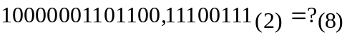
- 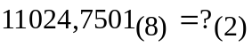
- 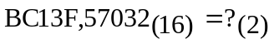
- 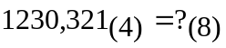
- 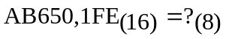
- 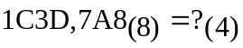
- 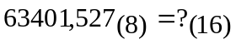
- 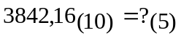
- 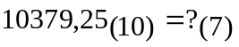
- 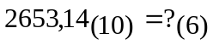
- 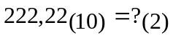
- 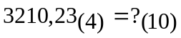
- 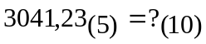
- 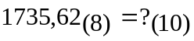
- 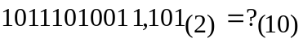
- 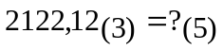
- 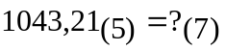
- 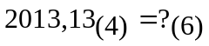
- 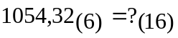
- 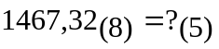
- 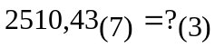
- 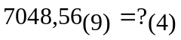
- 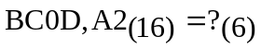

Results:
For 1-8 rapid conversions are applied:
- 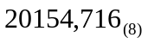
- 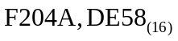
- 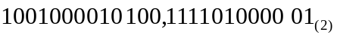
- 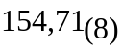
- 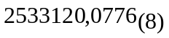
- 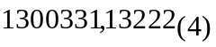
- 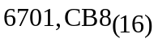
For 9-12 the method of successive divisions/multiplications is applied,
calculation in the source base: 10.
- 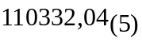
- 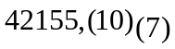
- 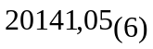
- 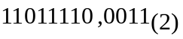
For 13-16 the substitution method is applied, calculation in the destination base: 10.
- 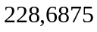
- 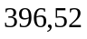
- 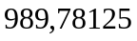
- 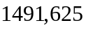
For 17-20 the substitution method is applied, calculation in the destination base.
- 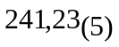
- 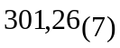
- 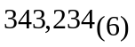
- 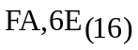
For 21-24 the method of successive divisions/multiplications is applied, calculation in the source base.
- 
 